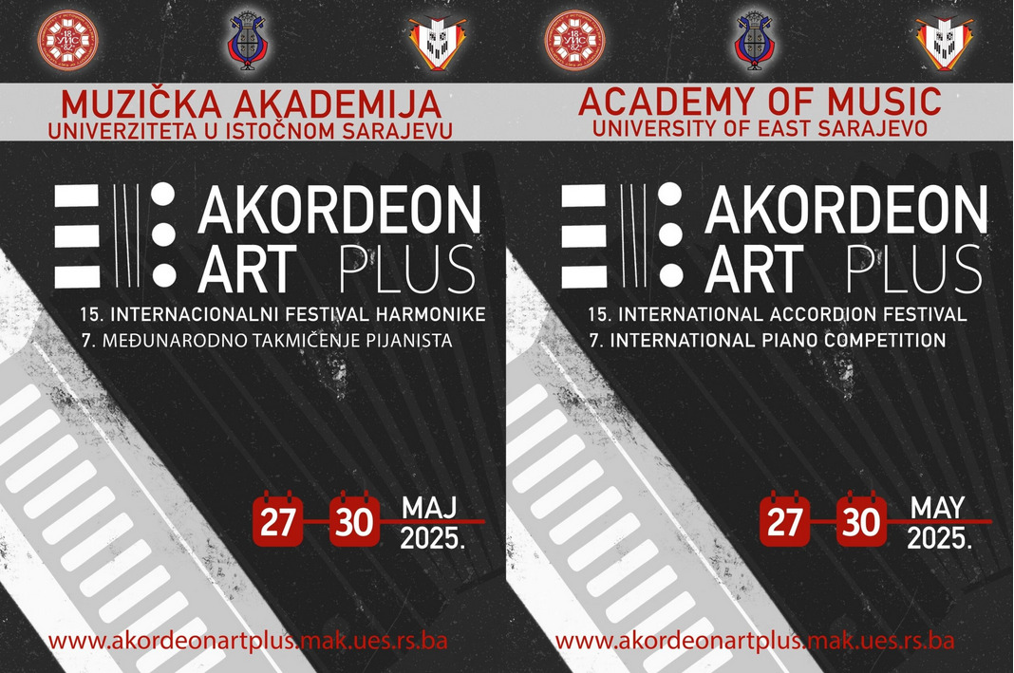

OBRAZAC PRIJAVE NASTAVNIKA* /
TEACHER APPLICATION FORM
Send to e-mail
akordeonart@mak.ues.rs.ba
(1st April – 23rd May 2025)
Ime i prezime nastavnika**/
Teacher’s name and surname
Broj mobilnog telefona i/ili e-mail /
Mobile phone number and/or e-mail
Muzička škola (akademija), grad, država/
Music school (academy), city, state
Ime studenta (učenika), e-mail (ili br. mobilnog telefona)
Student's name, e-mail (or mobile phone)
Disciplina, kategorija, broj bodova/
Discipline, Category, Score
*Informacije o nastavniku će se koristiti samo za kreiranje Potvrde učešća nastavnika na AKORDEON ART plus 2025/ Teacher's Information will only be used to create the teacher participation certificate at AKORDEON ART plus 2025.
** Potvrdu učešća nastavnika dobiće nastavnik čiji učenik je bio takmičar na AKORDEON ART plus 2025 / Teacher participation certificate will be given to a teacher whose student was a competitor at AKORDEON ART plus 2025.

